March 22, 2021
From: Bernie Adams, Systems Integration Specialist
To: Janean O’Brien Johnson, Fisher Parking & Security, Inc.
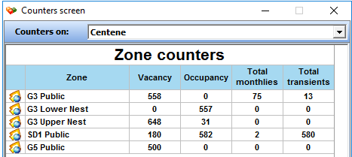
Subject: Estimate for Web Based Occupancy Group Counts Report for Centene Garage 3
This estimate is for creation of a web base Occupancy Group Counts Report for Centene for their Garage 3 TIBA PARCS. The report will generate hourly occupancy per group, per garage for a specified date range.
The web page supporting the reporting feature should be able to be loaded from any client with the designated authority to access the web page. The reporting web page will be designed such that adding subsequent reports will be able to be accomplished with little or no modification needed to the web page. No security will be built into the web page.
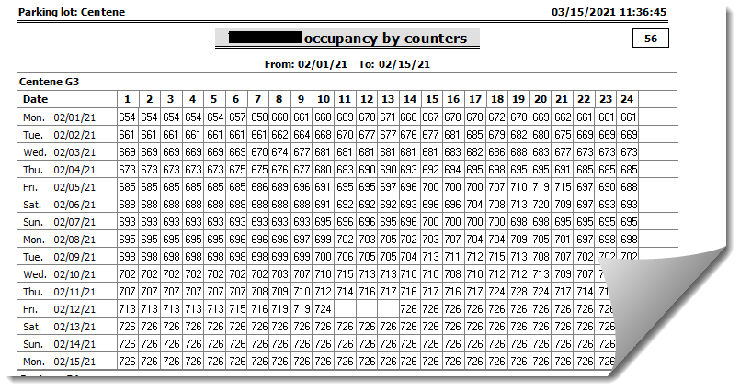
The Occupancy Group Counts report will be similar in format to the current TIBA reports 56/57/58 Occupancy by Counters. This is a sample, but does not reflect the actual final layout.
The report will display a combined occupancy for all parker types (transient, monthly cards and sensor only) per hour for each day for each group and average occupancy for each hour for the group, garage and overall.
The reporting web page be developed utilizing Microsoft ASP.net with backend coding in VB.net. The web page will require that Windows Internet Information Services (IIS) be installed on the TIBA SmartPark server along with enabling .NET 4.0.
PO Number:
Accepted By - Fisher Parking & Security, Inc.
Name/Title: ___________________________________________________________
Signature: _________________________________________ Dated: _________________________
QUOTE IS GOOD FOR 60 DAYS FROM THE DATE OF THIS DOCUMENT
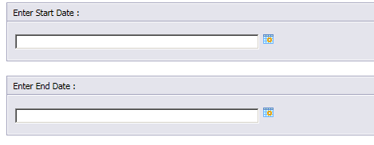
The Occupancy Group Counts report will be created with Crystal Reports version 13 and will require the installation of a Crystal Reports Runtime, compatible with the operating system version installed on the SmartPark server. (AMC will provide the supported runtime). When the report is invoked from the web page, the report will prompt for the necessary date range for the report. Report will be presented to the operator for viewing. The operator be able to print the report as well as export the report to various formats, such as Excel.
Non-Resettable counter data for the report will be extracted directly from the TIBA TBPARK database and associated database tables dbo.NRC_Counters, dbo.Parking_Lot , dbo.P_LaneDevice and dbo.P_Zones. Separate program will accumulate date into a custom database for reporting purposes.
Estimate includes: previous research, remote support in the setup and testing, 45-day warranty for adjustment after receipt of report. Estimated Cost for Web Based Group Counts Report: $5,500.00

