September 22, 2021

From: Bernie Adams, Systems Integration Specialist

To: Levi Rinkoff, TIBA Parking Systems

Subject: Theory of Operation and Estimate – OpenPath to TIBA SmartPark Interface

The purpose of this document is to define a theory of operations (TOO) for an integration between OpenPath and TIBA SmartPark. OpenPath is an access control system utilized in multiple industries. OpenPath is a reliable mobile access control with scalable cloud-based software and endless integration capabilities. Fast. Flexible. Future-proof.

TIBA and OpenPath desire to create an interface whereby the users of OpenPath access control system can utilize their credentials to access the TIBA SmartPark PARCS system. OpenPath will be the “master” in maintaining the users and credentials. Custom fields within OpenPath will be used to allow the specification of the company and the parking privileges to be used in SmartPark.

OpenPath has an API that can be utilize to retrieve user information for adding or updating users in SmartPark. The interface will be defined such that it can be scheduled to periodically look for new or updated users in OpenPath to add or update monthly parkers in SmartPark.

Theory of Operation

**Setup Items** – Coordination will be needed between an OpenPath site and the SmartPark PARCS system.

In SmartPark: the parking access items (Access Profiles) will need to be defined with unique numbers. The Access Profile numbers and description recorded for use in OpenPath. 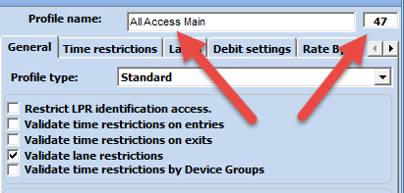

Additionally, all Companies and Sub Companies will be defined in SmartPark with a unique Accounting # (Company ID) recorded for use in OpenPath.

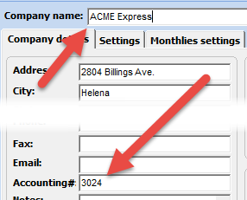

In OpenPath: the recorded Access profiles, Companies and Sub companies from SmartPark will be used to build values for dropdowns for several custom fields in OpenPath. Coordination between SmartPark and OpenPath is needed to ensure synchronization.

Suggested custom fields to be defined in OpenPath are:  
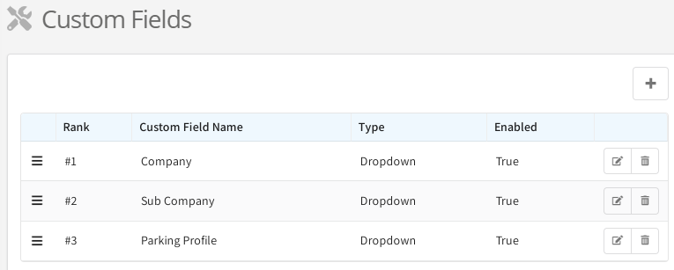

I.E. the access profiles in the OpenPath “Parking Profile” custom field dropdown:

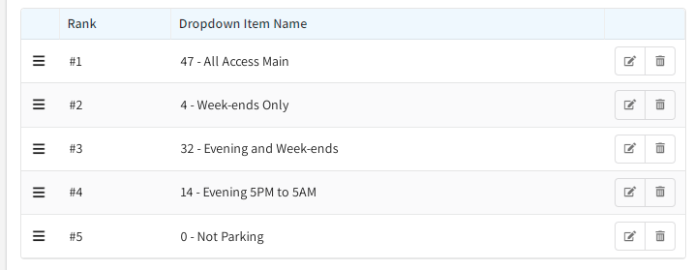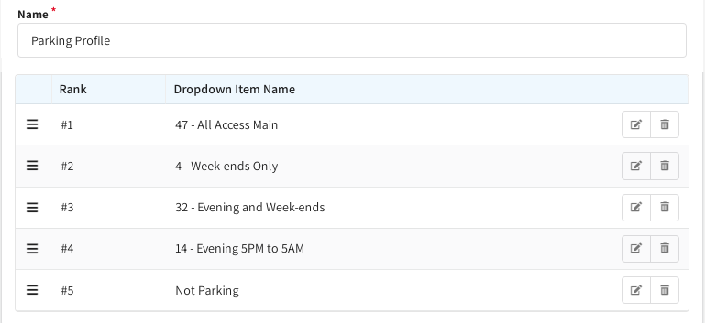

Note the custom field dropdown description will begin with the SmartPark defined Access profile number followed by a dash and then the description. This is important as the Access profile number is a critical value for adding and updating monthlies in SmartPark.

For Companies and Sub Companies, the same pattern should be used. In this case, the leading number is the Accounting # value for that Company/Sub-Company. For example:

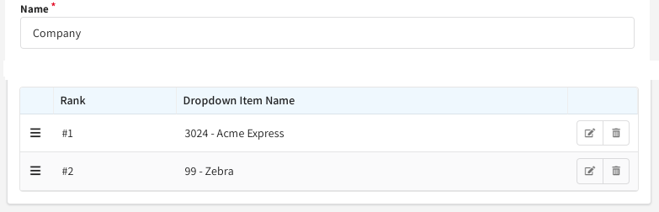

The defined dropdown lists will be presented to the OpenPath operator when adding or updating users. The operator would utilize the drop-down to select the pre-defined value to be saved with that user.

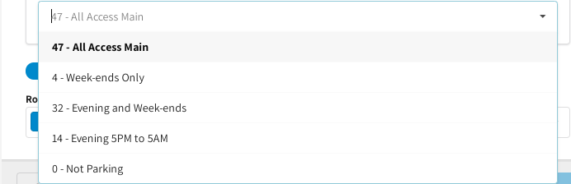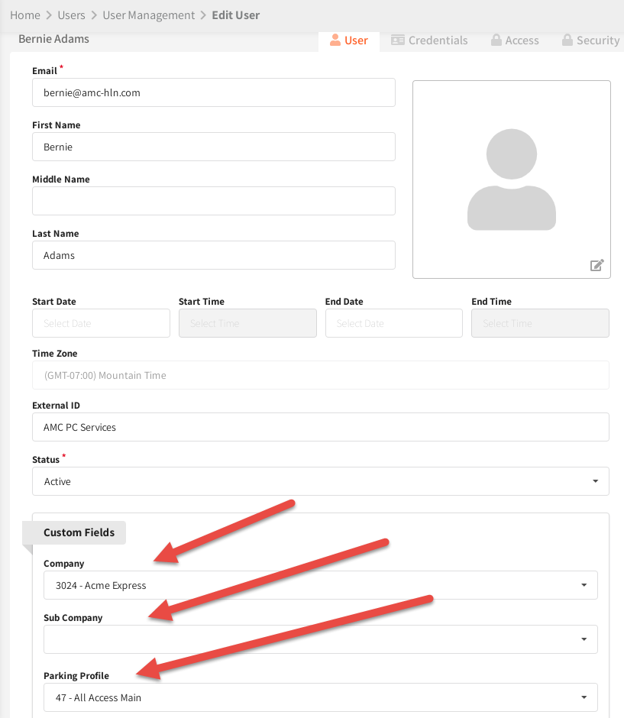

Setup items for the interface include the selection of a default access profile number and company ID in case the custom field value specified in the OpenPath custom field does not match an existing Access profile number, Company ID or Sub-Company ID.

The above setup items are in addition to the required parameters for the OpenPath API, SmartPark vendor API and SmartPark SQL Server connectivity.

 In SmartPark, an external vendor account will be defined for usage of the API (Tools/Tables/SmartConnect Vendor Accounts). AMC has been assigned vendor ID 57. Once the external vendor account is set up, the values will need to be provided for use in the TTSP program. The necessary values are: Facility ID, Vendor ID, Terminal number, user ID, password.

Additionally, the program will require the ability to connect to the TIBA SQL server for creating and using a custom database. Access to the TBPark database will be via API calls. Values need are: SQL Server instance address, SQL user name and SQL password.

For OpenPath, the required parameters will be: OpenPath URL, Org ID#, user name/email and password. OpenPath application will generate a security token to be used for communications to the OpenPath API.

Setup will also require retrieving the ID number from OpenPath for each of the custom fields defined in OpenPath. Specifically, the Custom field ID for Companies, Sub Companies and Access Profiles.

Additionally, the values defined for each of the custom fields retrieved will be saved in a custom SQL table for easier look-up during processing. A process will be created to periodically query for the values from OpenPath to ensure the latest items are available during processing.

There will be other setup items that will become apparent as the system is developed.

**Expected Programs, Processes and Databases** – The general list of the required programs and processes will be listed and their function.

Over All Menu – a button menu to make it easier to access the various processes and programs.

A custom database named AMC_SRP_DATABASE will be defined on the TIBASQL SQL server. The database will contain the setup items including the list of the values for each of the custom tables. There may be additional data or tables defined as needed to support the application.

General Setup – Process to define the “static” setup items and to map custom fields to their purposes (Company, Sub Company or Access Profile).

OpenPath Framework – process defined to verify OpenPath API operations, facilitate the proper parsing of data, standardize interactions and troubleshoot operation. Processes, modules and procedures defined in the framework will be utilized in any or all of the other programs or processes that require the features.

Refresh Custom Fields – process will be scheduled to run periodically (once a day) to query OpenPath for new Custom fields and for added or changed values for each custom field. Data will be used to update the AMC_SRP_DATABASE.

Changes Processing - Process that will query OpenPath for any changed user records for OpenPath since the last time the process ran. Data returned will be processed to add or update Monthly data in the SmartPark.

All processes will log their actions. If any critical error occurs related to data received from OpenPath (I.E. Company ID not found or Access Profile ID not found) will be recorded in a separate file. This allows the errors to be reviewed and corrections made to either SmartPark or to OpenPath. Each program or process will be responsible for purging older log and error files (older than 60 days).

**Changes Processing Overview**

Changes processing (CP) can be either run on-demand or as a scheduled task to run as frequently as desired. CP will first verify it can communicate to the SQL server hosting the AMC_SRP_DATABASE, OpenPath and to SmartPark API.

CP will login (https://api.openpath.com/auth/login) to OpenPath using the URL, user name and password to receive a token. Token value is used for authorization for subsequent API calls. (I.E. "token":"eyJhbGciO….”)

CP will proceed to retrieve a filtered list of active users (https://api.openpath.com/orgs/orgId/users) that changed since the last query of the user list. Only those users that have been assigned a parking profile in the defined custom field will be added or updated in SmartPark.

CP will examine the user entry returned and extract the name fields and custom field values from each record. CP will then retrieve the credential(s) for the user in OpenPath. If no credentials are found for the user, the user record is ignored.

The appropriate custom field value will be used to look up in the AMC_SRP_Database the associated Company ID, Sub Company ID and Access Profile ID. If the custom field for custom field Company is blank/0, the default Company will be used. If the Parking profile is blank/0, the default Access profile will be used.

CP will take the credential returned from OpenPath (right 9 digits) and either add or update a monthly record into SmartPark. The monthly record will be added or updated in SmartPark using the information returned from OpenPath user, custom fields and credential values.

A log of actions taken will be recorded for each row processed.

At the end of processing, CP will save the value of the last record processed (updated At date time). The saved value will be used for filtering to retrieve the next set of user changes.

SmartPark monthly fields affected by CP in adding and updating monthlies from OpenPath:

|  |  |  |
| --- | --- | --- |
| SmartPark Field | OpenPath Field | Notes |
| Company ID | Company – dropdown selected value | Custom Field – blank/0 - default Used |
| Sub-Company ID | Sub-Company – dropdown selected value | Custom Field - Optional |
| Badge Number | Credential | right 9 digits of credential |
| Monthly ID | User ID |  |
| First Name | First Name | left 20 chars – SmartPark limit |
| Last Name | Last Name | left 20 chars – SmartPark limit |
| Start Date | Start Date | default today |
| End Date | End Date | default 12/31/2049 |
| Access Profile | Parking Profile – dropdown selected value | Custom Field – blank/0 – default used |

Tasks:

Communications (meetings, TOO, etc.) – 6 hrs

Detailed documentation of OpenPath returned data and use – 4 hrs

Framework project for API communications to OpenPath – 16 hrs

Define custom database and tables – 2 hrs

Statement of Work/Design – hrs

Set-up Items dialogue – 4 hrs

Process OpenPath Changes to SmartPark program – 32 hrs

Installation program – 2 hrs

Internal testing – 4 hrs

Documentation – 2 hrs

Remote support for factory testing and for site installation and training – 8 hrs

Remote support/adjustments for 45 days after installation – 16 hrs

On-going Remote Support/adjustment after 45 days, up to 16 hours

ESTIMATED COST: $14,375.00

– Timeframe from Approval to factory test: 20 working days.