February 27, 2020
From: Bernie Adams, Systems Integration Specialist
To: Jay O’Brien, FISHER PARKING & SECURITY
Subject: City of Coralville, Spectra, TIBA & Paciolan Parking support at Xtream Arena
This document will provide a not-to-exceed quote for creating an interface for the City of Coralville. The AMC Paciolan to TIBA interface (APTI) would be used to import parking reservation information from a Paciolan system and adding the reservation to the TIBA Parking system eReservation system.
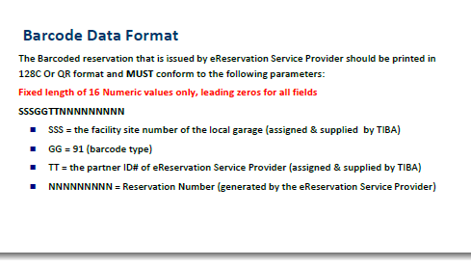
When a patron purchases an event ticket through Paciolan, a parking pass will also be generated. Currently, anybody that purchases an event ticket will receive a parking pass at no extra cost. The parking pass generated by Paciolan will be a separate barcode or QR code that is properly formatted to be read by the TIBA parking system and be recognized as an eReservation. Required barcode format and general content have been provided to Paciolan and is displayed on the right.
TIBA/Fisher Parking will need to provide to Paciolan two key pieces of information to be used in the parking barcode. A 3 digit facility site number and assign a 2 digit partner ID number for Paciolan.
When an event ticket is purchased, the data related to the event ticket and the subsequent parking pass barcode will be stored in a database maintained by Paciolan. The APTI will periodically query the Paciolan database for any new or changed events tickets with parking. Any new/changed event tickets with parking passes will be used to create/update a TIBA eReservation record. Each eReservation will have a date/time range of validity and be allowed a single use in that time period.
The APTI will be able to be scheduled to launch on a periodic basis or will be able to be run manually at any time. APTI will track the last event ticket found in the Paciolan database so that on the next run, it will find only the new or changed items. Several setup items (yet to be finalized) will be required to connect to the Paciolan database and items necessary to be used in processing of the parking reservations into the TIBA eReservation system. APTI will log all actions and errors for audit and troubleshooting purposes. Project does not require any reporting on the data processed from Paciolan and Paciolan does not require update of the status of the eReservations from TIBA.
Cost includes weekly meetings, reviews, documents, etc. as well as the actual programming project with testing, adjustments, documentation and remote support for 45 days after install. On-site time and expenses are extra.
Quoted cost for AMC Paciolan to TIBA interface (APTI): $8,750.00
QUOTE IS GOOD FOR 60 DAYS FROM THE DATE OF THIS DOCUMENT
Accepted By - FISHER PARKING & SECURITY
Name/Title: ________________________________________
Signature: _________________________________________ Dated: _______________________
PO Number:

