[Publish Date]
From: Bernie Adams, Systems Integration Specialist
To: Paul Hayes, TIBA Parking
Subject: Estimate for Enhancements for Rochester T2 Import
The estimate below is for enhancements related to the Rochester T2 Import. The estimate takes into consideration the amount from the previous quote provided September 2nd to determine this estimate. The requests are currently considered specific to Rochester.
Requested enhancements are related to certain columns contained in the T2 Import file:
- PSL_Description - The field relates to the current status of a monthly. The field can contain one of these values: Active, Issued, Deactivated, Expired, Returned and Missing. The request is to utilize the values to determine the MType for the associated monthly in TIBA.
- PNA_SERIES_PREFIX- If the value in this field is not blank, then the value can be mapped to a TIBA access profile.
- VEH_PLATE_LICENSE – The field will contain the license plate for a registered vehicle. There may be one or more vehicles attached to monthly. Currently, there are issues with the vehicle data from Rochester.
Operational Flow for each of the enhancements
PSL_Description – monthly status
The enhancement for utilizing the PSL_Description to denote the MType of a monthly will be implemented by hard-coding the expected values. If a different value is received in the CSV file than the hard-coded values, then the default MType will be used.
Processing: When a row in the CSV file is being processed, if the value in the PSL_Description field matches one of the expected values (Active, Issued, Deactivated, Expired, Returned or Missing) The MType will be set accordingly. If the value in the field is blank or does not match one of the aforementioned values, the default MType will be used.
The expected PSL_Description values and their mapping to the TIBA MTypes will be coded as follows: Active and Issued = Standard (2), Deactivated, Expired, Returned and Missing = Blocked (0)
PNA_SERIES_PREFIX– Access Profile
The enhancement for utilizing the PNA_SERIES_PREFIXto define the TIBA Access Profile will be implemented by adding a feature to allow the mapping of the expected values to one of the sites TIBA Access Profile numbers.
The mapping program will be accessed via a new command button on the existing processing form. The mapping program will utilize the same TIBA API settings from the main form to simplify use. When the form is loaded, it will automatically connect to the TIBA SmartPark system to pull a list of the existing access profiles on the TIBA system to be used for mapping. Additionally, if previous mappings have been setup, a list of these mapping will be displayed as well.
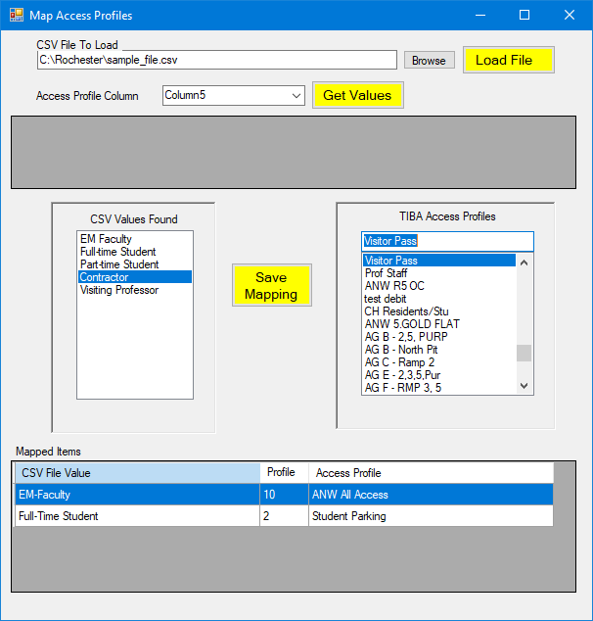
The graphic shown is for the purpose of visualizing the operations of the mapping program. The actual program may appear differently.
The user will select a representative CSV file and load it. The contents will appear in the grid at the top of the form. The user will select the column that contains the access profile values (I.E. PNA_SERIES_PREFIX) and click the ‘Get Values’ button. The program will parse the file and build a list of the unique values found in the specified column. These values will be used to simplify the mapping.
To map a prefix with an access profile, the user will select one of the values in the left list and the associated access profile from the right list and click ‘Save Mapping’ button. The mapping will appear in the grid on the bottom of the form.
Mappings can be removed by deleting them from the grid. As each new mapping is created or removed, the program will save the mapping list.
Processing: When the import program is started, the defined mappings will be loaded for use during the imports. As each row is processed from the import file, the program will determine if the value in Access Profile (I.E. PNA_SERIES_PREFIX) specified column contains a value that either matches a known Access Profile number or can be found in the defined mappings. If a match is made, then the associated access profile value will be used to populate the access profile field for the monthly. If no match is found, then the default access profile will be used.
VEH_PLATE_LICENSE – Multi-vehicle
The CSV file for a particular employee/badge may have one or more rows of information with the only difference being the vehicle information (VEH_PLATE_LICENSE, VKL_DESCRIPTION, VML_DESCRIPTION, VCL_DESCRIPTION). The user will specify the column that contains the plate. It is expected that the following three columns contain the make, model and color. The key value is the license plate.
If no column is selected for the license plate field, then all monthlies added or updated in SmartPark will be saved with no vehicles. If previously there were vehicles assigned to a monthly, these will be lost.
SmartPark has a limitation of five (5) license plates per badge. If a particular badge has more than 5 unique license plates defined, only the first 5 unique plates will be updated for that monthly. Additionally, SmartPark does not allow duplicate license plates. If an attempt is made to add or update a monthly badge and a duplicate license plate error is returned, the program will remove all vehicle information from that badge and update the monthly without vehicles assigned.
Processing: When the program loads the import file for processing, it will sort it by the column denoted to hold the badge number and then by the column denoted to hold the license plate. If a column was not designated for the license plate, then the data is sorted by badge number only.
As the rows are processed from the import file, if there is a license plate value in that row, the vehicle information will be placed in the first license plate slot. If the subsequent row is for the same badge and the license plate field is not blank, the program will check if the license plate was already “seen” by checking it against the license plates already read. If no match is made, then the license plate is placed in the next slot. Once there are five license plates defined, all others will be rejected for that badge.
The monthly record for that badge will then be added or updated in SmartPark. If a duplicate license plate error is returned, the program will remove all vehicle information from that badge and update the monthly without vehicles assigned. The error will be logged for review.
ESTIMATED ENHANCEMENT COSTS
$500.00 | PSL_Description – Set MType
$1,850.00 | ENT_GROUP_NAME – Mapping Access Profiles
$1,250.00 | VEH_PLATE_LICENSE – Multiple license plate  Accepted By - Vendor name  Name/Title: ___________________________________________________________  Signature: _________________________________________ Dated: _________________________
$250.00 | Testing and Support
$3,850.00 | TOTAL ENHANCEMENT COSTS
QUOTE IS GOOD FOR 60 DAYS FROM THE DATE OF THIS DOCUMENT
PO Number:
Accepted By – TIBA Parking
Name/Title: ___________________________________________________________
Signature: _________________________________________ Dated: _________________________

