September 2, 2022
From: Bernie Adams, Systems Integration Specialist
To: Mor Ynon, TIBA Parking US
Subject: Quote for SmartPark CSV file import for Rochester T2 Import
The quote below is for the creation of a T2 CSV file import utility for Rochester to the TIBA SmartPark system. The utility will be built using the TIBA SmartConnect API. The purpose for the utility is to allow Rochester to be able to import new and updated monthly parker subscriber information (Student and Faculty). The import will be used to set up a new monthly parker subscriber or update an existing subscriber and its units.
The T2 CSV is expected to contain one or more rows of data to import. The fields or elements on each row being separated by commas. Any text field that has a potential of containing a single quote or comma (I.E., “O’Brien” or “AMC PC Services, LLC”) as a part of its value should be surrounded by double quotes.
The utility will allow the technician to “map” the individual fields of a row in the T2 CSV file to pertinent fields within SmartPark. Not all fields in a data row of the T2 CSV file need to be mapped.
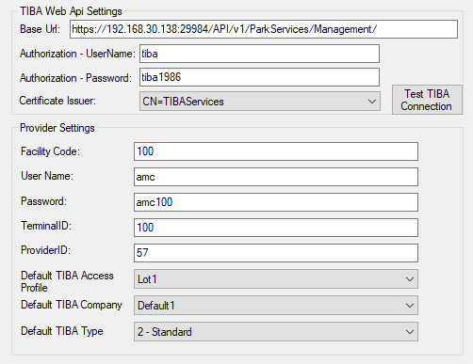
Standard setup of the utility will require the technician to know the base URL (and port if necessary) to access the SmartConnect Park Service Management API (I.E. https://customer.tibaparking.net:29984/API/v1/ParkServices/Management/) along with the proper external vendor provider settings. It is assumed the technician understands the necessary licensing and setup required in SmartPark for the settings.
Also, within SmartPark, there needs to be at least one Company with a unique Accounting #, and one Access Profile with a unique ID defined that can be used as default values for the imported data.
Once the above items are defined, tested and selected, the technician can then proceed to select the T2 CSV file to be processed, map the fields from the T2 CSV file to the appropriate SmartPark field and process the file. Utility will allow for the selecting of one or more vehicles to a badge. License plates are expected to be unique across all badges.

Any field from the T2 CSV file can be mapped to multiple SmartPark fields. At a minimum, the technician must specify the field that contains the unique numeric value of the badge and also the unique value to be used to identify the subscriber (Monthly ID).
When mapping a field, a list of the generic column names will be presented. The technician will select the column that contains the desired value for the specified SmartPark field.
For the Start Date and End Date SmartPark fields, if no CSV file columns are selected, the current date will be used for the start date and 12-31-2050 will be used for the expiry date. Do note that if date(s) are selected from the columns of the T2 CSV file, the technician must observe the format of the date in the T2 CSV file column and select the proper format. European date implies that the date in the CSV file is represented as day-month-year (I.E. June 29, 2022 would look similar to: 29-06-2022). Once the technician is satisfied with the specified mapping, the T2 CSV file can be processed and results reviewed in SmartPark. The technician would also be able to review the log file generated by the utility for any errors that may need to be resolved.
During processing, the utility will display status messages and generate a log file containing messages related to the processing, including any errors. Errors can consist of non-numeric badge number, invalid dates and so forth. At the end of processing, the utility will report statistics on the data processed (I.E. number of rows processed, error count, etc). Any given file can be reprocessed as the utility will add new monthly subscribers and update existing monthly subscribers’ information in SmartPark.
It will be the responsibility of Rochester to maintain the processed CSV files and to either archive them or delete them. The utility will maintain the log files generated by the utility.
For testing the utility and installing at Rochester, it will be required that Rochester provide one or more sample T2 CSV files. Without sample T2 CSV files, it will not be possible to guarantee success of imports of any of their T2 CSV files.
NOTE: The utility will only allow manual processing of individual T2 CSV files. It will not be able to be automated to run unattended.

Quote for T2 CSV File Import to TIBA SmartPark for Rochester
Detailed below are the tasks, estimated hours and costs involved to create the T2 CSV file Import integration to TIBA SmartPark for Rochester.
Task Description
Communications (meetings, discussions, etc.)
Program to process T2 CSV file to SmartPark
Installation program and documentation, Internal testing and adjustments
Remote support for testing, installation, training, and 45-day warranty period
On-going Remote Support/adjustment after warranty period
TOTAL ESTIMATED COST: $4,375.00
– Timeframe from Approval to factory test: 15 working days.
QUOTE IS GOOD FOR 90 DAYS FROM THE DATE OF THIS DOCUMENT

Accepted By – TIBA Parking USA
Name/Title: ________________________________________
Signature: _________________________________________ Dated: ______________

