Coralville Event Parking TIBA Interface Application
Installation and User’s Guide

Created by:
Automation & Management Consulting, LLC
Event Parking TIBA
Interface Application 07-29-2020

Table of Contents
Project Overview 3
Interface Program Processing Overview 4
Installation 6
Coralville Event Parking Interface 10
Settings Form 10
Coralville Event Parking File Processing 12
How to Set a Program to Run Using Task Scheduler 13
Activity Log 18

Project Overview
Overview:

When a patron purchases an event ticket through Paciolan, a parking pass will also be generated.
Currently, anybody that purchases an event ticket will receive a parking pass at no extra cost. The parking pass generated by Paciolan will be a separate barcode or QR code that is properly formatted to be read by the TIBA parking system and be recognized as an e-Reservation. A required barcode format and general content have been provided to Paciolan.
TIBA or Fisher Parking will provide to Paciolan two key pieces of information to be used in the
parking barcode. A 3-digit facility site number and assign a 2-digit partner ID number for Paciolan.
When an event ticket is purchased, the data related to the event ticket and the subsequent parking pass
barcode will be stored in a database maintained by Paciolan. The APTI will periodically query the
Paciolan database for any new or changed events tickets with parking. Any new or changed event tickets
with parking passes will be used to create or update a TIBA e-Reservation record. Each e-Reservation will
have a date/time range of validity and be allowed a single use in that time period.

The APTI will be able to be scheduled to launch on a periodic basis or will be able to be run manually at
any time. APTI will track the last event ticket found in the Paciolan database so that on the next run, it
will find only the new or changed items. Several setup items will be required to connect to the Paciolan database and items necessary to be used in processing of the parking reservations into the TIBA e-Reservation system. APTI will log all actions and errors for audit and troubleshooting purposes.

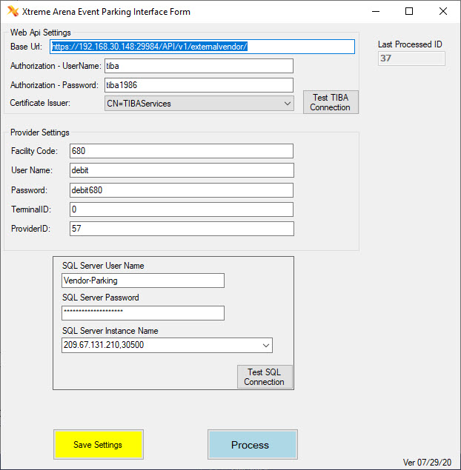

Setup Items –
Before processing and transferring of any Paciolan reservations can take place, the following setup items need to be defined for the interface program.
Base URL – This is the URL address of the TIBA Server appended with the API name which in this application is ParkServices/Management/.
Authorization User Name – This is the authorization user name which for this application is tiba.

Authorization Password – This is the authorization password which for this application is tiba 1986.

Certificate Issuer – This is the certificate code from TIBA which for this application is CN=TIBAServices.

Facility Code – This is the facility code or the site id.

Username – This is the user name needed to connect to TIBA API. This is defined by establishing an external account in TIBA.

Password – This is the password needed to connect to the TIBA API. . This is defined by establishing an external account in TIBA.

Terminal ID – This is the terminal ID necessary to connect to the TIBA API. . This is defined by establishing an external account in TIBA.

Provider ID – This is the provider ID necessary to connect to the TIBA API. . This is defined by establishing an external account in TIBA.

SQL Server Name - This is the SQL Server Name provided by Paciolan that allows the user to connect to the Paciolan database defined specifically to retrieve the parking records for the Xtreme arena events.

SQL Server User Name - This is the SQL Server User Name provided by Paciolan that allows the user to connect to the Paciolan database defined specifically to retrieve the parking records for the Xtreme arena events.

SQL Server Password - This is the SQL Server password provided by Paciolan that allows the user to connect to the Paciolan database defined specifically to retrieve the parking records for the Xtreme arena events.

Interface Program Processing Overview

Interface Program processing:
- On a user defined basis, this could be hourly or every 10 minutes the TIBA Paciolan Interface application will retrieve all e-Reservation parking records from Paciolan since the last time the application ran and add or update e-Reservation records in the TIBA Smart Park system.

- Process will generate a log file called yyyyMmdd.csv and is located in the C:\AMCLOGS\[application name] folder. The CSV file will contain the Barcode ID, Transaction Date/Time, Event Description and ID, First Name, Last Name, and Valid From and To Dates An example is shown below:

"Program","Transaction _DateTime","Message_Origin","Message_1","Message_2","Message_3","Message_4"
"CoralVilleEventParking","#2020-07-20 07:29:26.211#","Added New Reservation Successfully","BarCode: 7119157999100001","","",""
"CoralVilleEventParking","#2020-07-20 07:30:47.512#","Added New Reservation Successfully","BarCode: 7119157999100002","","",""
"CoralVilleEventParking","#2020-07-20 07:31:34.567#","Added New Reservation Successfully","BarCode: 7119157999100003","","",""
"CoralVilleEventParking","#2020-07-20 07:32:57.717#","Added New Reservation Successfully","BarCode: 7119157999100004","","",""
"CoralVilleEventParking","#2020-07-20 07:43:21.936#","Added New Reservation Successfully","BarCode: 7119157999100005","","",""
"CoralVilleEventParking","#2020-07-20 07:44:07.775#","Added New Reservation Successfully","BarCode: 7119157999100006","","",""
"CoralVilleEventParking","#2020-07-20 07:44:46.710#","Added New Reservation Successfully","BarCode: 7119157999100007","","",""
"CoralVilleEventParking","#2020-07-20 07:45:30.345#","Added New Reservation Successfully","BarCode: 7119157999100008","","",""
"CoralVilleEventParking","#2020-07-20 07:46:17.030#","Added New Reservation Successfully","BarCode: 7119157999100009","","",""
"CoralVilleEventParking","#2020-07-20 07:46:58.573#","Added New Reservation Successfully","BarCode: 7119157999100010","","",""
"CoralVilleEventParking","#2020-07-20 07:57:46.710#","CoralVilleEventParking","Delete Reservation successful: 6809157999100011","","",""
"CoralVilleEventParking","#2020-07-20 07:58:01.970#","Deleted Existing Reservation Successfully","BarCode: 7119157999100011","","",""
"CoralVilleEventParking","#2020-07-20 07:58:42.869#","End of Processing - Overall Records: 1 - Processed: 1 Errors: 0 - New Reservations: 0 Updated Reservations: 0 Canceled Reservations: 1","Xtreme Arena Event Parking Interface Form","PROCESSING COMPLETE","",""

This file can be opened in Excel for review and printed as a report. These csv files will be retained for 60 days in this folder and then deleted.

Installation
Double click the setup.exe file. The following screen will appear:

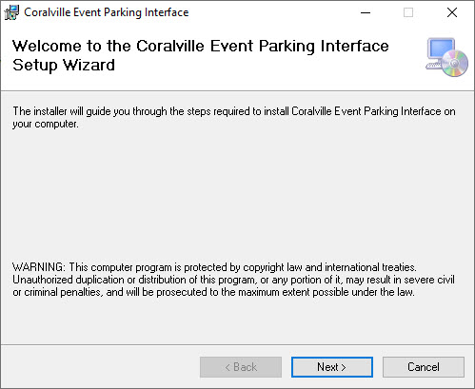

Click ‘Next’

The following screen will appear:

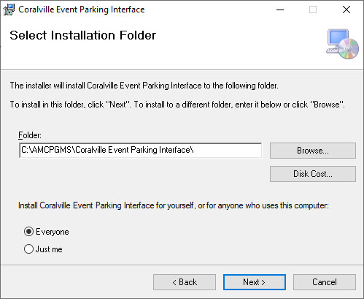

The user can determine where the application will install by clicking ‘Browse’, then selecting a folder. The user can also specify who can use this specific interface by clicking one of the two options, ‘everyone’ or ‘just me’. After the necessary changes are made, click ‘next’.
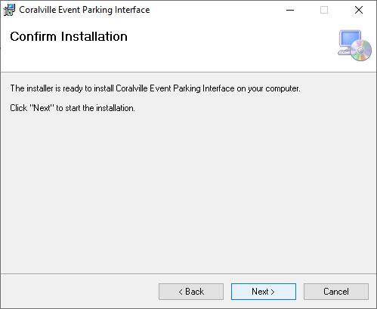

To continue with the installation, click ‘next’. (If changes need to be made for the installation destination or who can use the interface, press the ‘back’ button.). The application setup will take a few moments to install. Progress of the installation will be shown in the rectangular bar with the message of ‘please wait’.
When completed the installation complete screen will automatically be displayed.
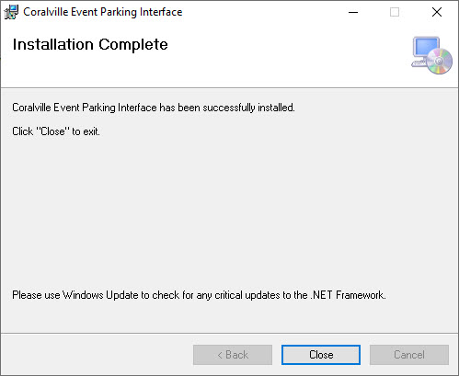
Click ‘close’ to exit the installation program. Coralville Event Parking Interface application is now installed.
One icon will appear on the desktop, as shown below:

Coralville Event Parking Interface Function:
Setup Parameters and Select Process to retrieve e-Reservation records from Paciolan and add or update records in the TIBA Smart Park system.

Coralville Event Parking Interface

Settings Form
To use the Coralville Event Parking Interface Software, the user must first open the application by finding the shortcut ‘Coralville Event Parking Interface’ (shown on the previous page) and double clicking on it. The following screen appears:

By running the application manually the first time the operator can enter the appropriate settings information, test the connections and save the settings by clicking the SAVE SETTINGS button on the bottom of the form. PLEASE NOTE: This must be completed before the user can process any e-Reservation records.

The user can test the connection to the Server by clicking the ‘TEST CONNECTION’ button. If the connection is successful the following popup screen will appear indicating a successful attempt.

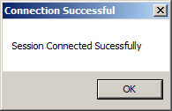

If not successful then the following popup will appear. The user should click the OK button and then fill in the correct setup information and click the test button until a successful connection has been established.

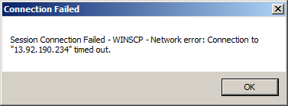

Coralville Event Parking File Processing
Once all of the setup information is complete and the user should click the Test TIBA Connection button to make sure that they have the proper connection to the TIBA SmartPark database. They should also click the Test SQL Connection button to make sure they can connect to the Paciolan database. If either of these tests fail determine if the settings parameters are correct. Once the user can connect to TIBA SmartPark and Paciolan, the user can then schedule the process to run as often as necessary. The user may decide that this process needs to run as often as every 10 minutes or perhaps hourly. Once this task has been scheduled it will start at the scheduled time and process all of the e-Reservation records in the Paciolan database and add or update these records in the TIBA Smart Park system. These e-Reservation records can be used once during the valid from and to times defined in the Paciolan database for the event. If the event changes times the interface application will update all records currently in the TIBA SmartPark system with the modified times for that event. If the event cancels Paciolan will place cancelation records which will be picked up by the interface application and all e-Reservations records for this event in TIBA SmartPark will be canceled. The process will output a .csv log file with all records that were cancelled. This application will automatically close when it has finished processing.

To schedule a task the user should click on the Windows START button and select ADMINISTRATIVE TOOLS and then select Task Scheduler. See the section, “How to set a program to run utilizing the task scheduler” for more information on how to schedule the Coralville Event Parking Interface process program.

. PLEASE NOTE: The user needs to specify an argument value. Enter in ‘AUTO’ to have the program recognize that it is being run from a scheduler, which will then open the program, process the data, and then close the application all automatically. Click ‘OK’ to save the action settings.

How to Set a Program to Run Using Task Scheduler
Users have the ability to begin a program automatically. This is done by setting a combination of a trigger and action within Windows Task Scheduler to have the application run automatically. The trigger determines when and how often to run the program. The action determines what action will occur (i.e. run a program) and specifies which program to run by selecting the folder path and executable name. The user will also need to create a shortcut with an argument so the program recognized its being run from the scheduler.

Before setting up a program to run automatically, it is necessary that the setup for the program itself has been completed.

1. To create a task at a specific time, perform the following steps.
a. Click the ‘Start’ button (shown right). Select ‘Control Panel’ on the right side of the menu.

b. The Control Panel is shown below. Double click ‘Administrative Tools’.

c. Select ‘Task Scheduler’.

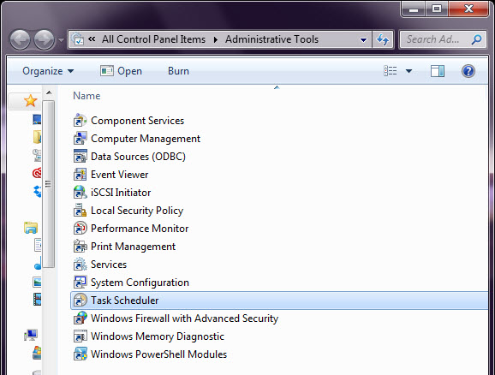

d. Below is the main task scheduler window. Select ‘Create Task…’ on the right hand side.
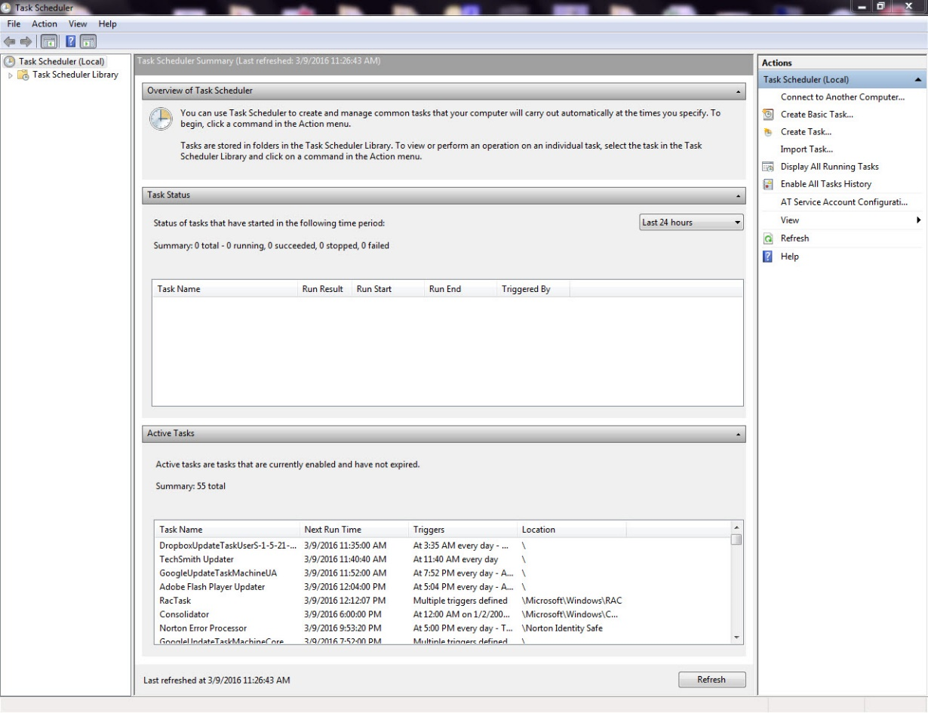

e. Under the ‘General’ tab, enter in the name of the task. This will be the name displayed on the main task screen, under ‘Active Tasks’ (shown above). The location and description are optional. Under Security options, choose which user accounts run the task. Make sure ‘Run with highest privileges’ is selected.

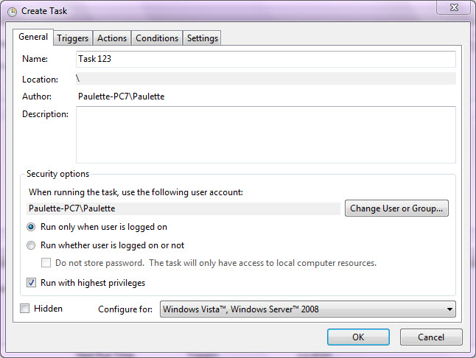

f. Next, click the ‘Triggers’ tab on the ‘Create Task’ window. Choose when to begin the task from the list of dropdown options shown below.
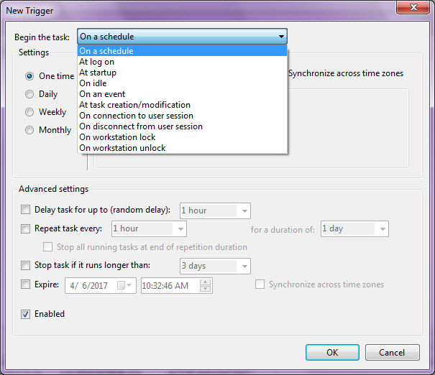

g. It is recommended to trigger the task ‘On a schedule’. In this example the trigger is set to begin on a schedule. It is scheduled to start on April 27th, 2016 at noon and will run every hour on the hour indefinitely. For this application the schedule should start at 3:00 AM and run every day.

The user selects the start date and time. It is important that the user sets the frequency the task will be triggered as well as the duration that the task will be triggered for. This is done by selecting an option from the drop down menu(s). To save the trigger settings click ‘OK’.

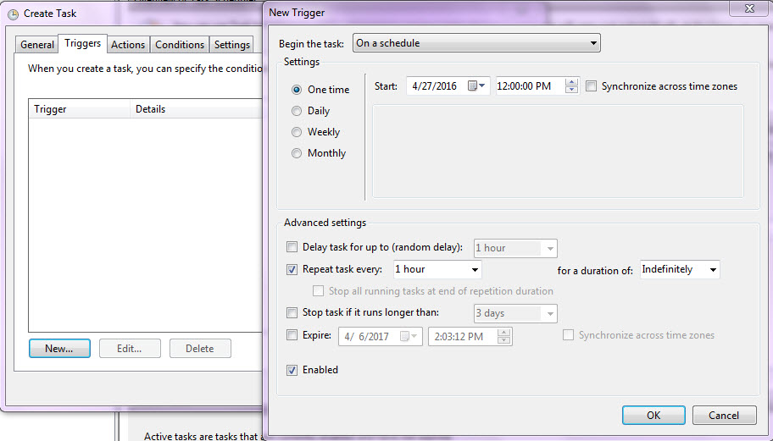

h. Next click the ‘Actions’ tab on the ‘Create Task’ window. Click ‘New’. This is where the user will specify what action the task will perform. In this example the action will start a program, specifically ccleaner, which was selected by clicking ‘browse’ on the computer, then selecting the program to be run. The argument is set at ‘AUTO’ which makes the program recognize that it is being run from the scheduler. For this application the user will select ‘TIBA HR Interface’ from the installation folder.

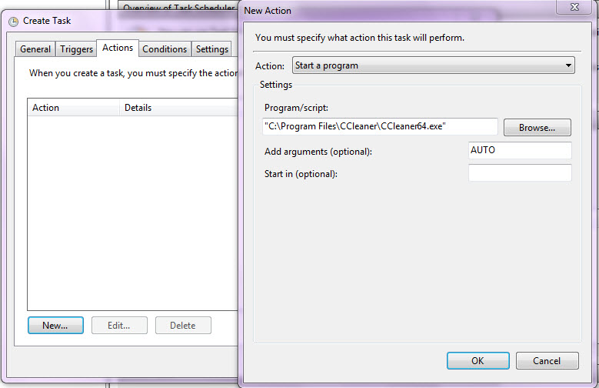
Choose the action of ‘Start a program’. Next click ‘Browse’ to find and select the folder path and executable name. An argument must also be specified at this time. Enter in ‘AUTO’ to have the program recognize that it is being run from a scheduler, which will then open the program, process the data, and then close the application all automatically. Click ‘OK’ to save the action settings.

Click ‘OK’ to create the task. The new task will now appear on the main task scheduler screen signifying that it has been successfully setup.

Activity Log
The activity log contains the information on the files processed and tracks any data errors that are encountered.
As each import file is processed, the information is recorded in the Interface Activity Log. Each day, a singular log file is created which contains the details of the day’s activity. The file resides in the install folder of the application.
The file is named “YYYY-MM-DD.log”
YYYY = year
MM = month
DD = day

The log file contains the following fields:

Field Name | Type | Size | Sample Data | Comments
Transaction Date and Time | DT |  | 2013-01-25 14:30:21 | Date and time the log entry was written
Program or Form | C | 50 | LoginForm1 | Form name or application name
Description | C | 250 | Processed file ‘XYZABC.txt’ | Contains the name of the file processed or the text of the error
Additional Info | C | 250 | Ww records processed, xx cards added, yy cards deleted, zz changed | Supplemental information for error or processing

Sample Data:
"Program","Transaction _DateTime","Message_Origin","Message_1","Message_2","Message_3","Message_4"
"CoralVilleEventParking","#2020-07-20 07:29:26.211#","Added New Reservation Successfully","BarCode: 7119157999100001","","",""
"CoralVilleEventParking","#2020-07-20 07:44:46.710#","Added New Reservation Successfully","BarCode: 7119157999100007","","",""
"CoralVilleEventParking","#2020-07-20 07:45:30.345#","Added New Reservation Successfully","BarCode: 7119157999100008","","",""
"CoralVilleEventParking","#2020-07-20 07:46:17.030#","Added New Reservation Successfully","BarCode: 7119157999100009","","",""
"CoralVilleEventParking","#2020-07-20 07:46:58.573#","Added New Reservation Successfully","BarCode: 7119157999100010","","",""
"CoralVilleEventParking","#2020-07-20 07:57:46.710#","CoralVilleEventParking","Delete Reservation successful: 6809157999100011","","",""
"CoralVilleEventParking","#2020-07-20 07:58:01.970#","Deleted Existing Reservation Successfully","BarCode: 7119157999100011","","",""
"CoralVilleEventParking","#2020-07-20 07:58:42.869#","End of Processing - Overall Records: 1 - Processed: 1 Errors: 0 - New Reservations: 0 Updated Reservations: 0 Canceled Reservations: 1","Xtreme Arena Event Parking Interface Form","PROCESSING COMPLETE","",""

